Republic of Moldova
The Czech Office for Standards, Metrology and Testing (ÚNMZ) signed with the Czech Development Agency Agreement on implementation of the Project Development Cooperation with the Republic of Moldova named “Implementation of the Eurocodes in the Republic of Moldova”.
Ref. | Project title |  | IMPLEMENTATION OF THE EUROCODES IN THE REPUBLIC OF MOLDOVA
Name of legal entity | Country | Total Project budget | Proportion carried out by legal entity (%) | No of staff provided | Name of client | Origin of funding | Dates (start/end) | Name of consortium members, if any
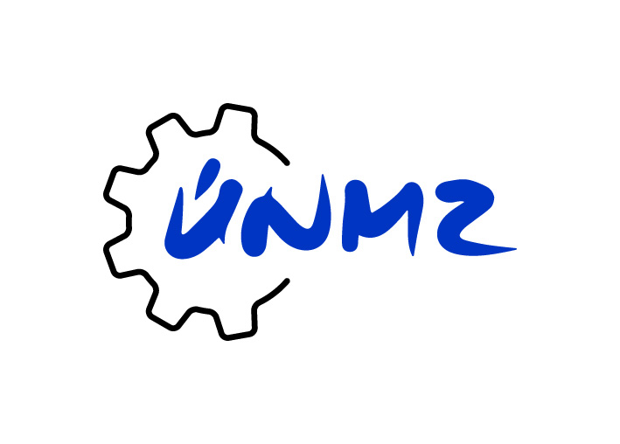 | Republic of Moldova | 5 448 900 CZK | 100 % | 13 | Ministry of Economy and Infrastructure | Development Aid of the Czech Republic | 09/2016 - 07/2020 | -
Detailed description of Project |  |  |  |  |  | Predefined Project Objectives
Summary of the Project  The main objective of the Project was to support the implementation of the unified European procedure for designing building structures in the Republic of Moldova. The attainment of the given objective was contributed by strengthening professional capacities and technical assistance in the preparation, design and implementation of national annexes to selected unified European normative documents for the design of buildings and civil engineering in terms of mechanical resistance, stability and fire resistance – so called Eurocodes. Benefiting from using European and international standards the Republic of Moldova approached to the European Union, which helps to foreign investors to easier access to the Moldovan market and to Moldovan companies to entry to the EU market.  The success rate of Eurocodes implementation was also increased by providing of easy access of the general expert public and all interested parties to the relevant international, European and national standards and normative documents. This was achieved by creating a modern information electronic system for on-line access to standards.  Overall objective of the Project  The Project intended to contribute to the fulfilment of Sustainable Development Objective 9.1 – Development of Quality, Reliable, Sustainable and Resilient Infrastructure by supporting and strengthening the process of implementation of the unified European Rules for designing and verifying the reliability of building structures – Eurocodes, which contributed to increasing of the safety and quality of constructions, including ensuring the access of the general public to these and other normative documents.  Outcome of the Project  The outcome of the Project was to implement the unified European procedure for designing building structures in the Republic of Moldova. This outcome was achieved by strengthening the functional structure in the area of the implementation, creation and preparation of national annexes to unified principles for designing structures – Eurocodes and by extending the existing distribution system of standards to the order system. |  |  |  |  |  | - Increasing of professional capacities in the area of Eurocodes  - Organisation and implementation of seminars for the expert public, employees of relevant institutions and government bodies  - Professional preparation partner´s capacities focusing on implementation of national annexes to Eurocodes 0 and 1; preparation of the national Eurocode implementation strategy; preparation of national standardization bodies for the performance of the function of certification body for certification of persons and accreditation  - Strengthening of the application of Eurocodes to practice by establishing a trial version SW tools for the use of Eurocodes  - Strengthening of technical capacities of selected laboratories for verification of characteristic properties of construction products according to European standards  - Processing of national annexes to selected Eurocodes and their publication  - Coordination of activity of the Technical Committee structure leading to the preparation of national annexes, including the data calibration  - Publication (in electronic form) of professional study materials for the application of selected Eurocodes in the national language  - Expansion of the existing distribution system of standards with order system  - Processing of the analysis and technical requirements for the SW application to ensure secure access to standards and their distribution

